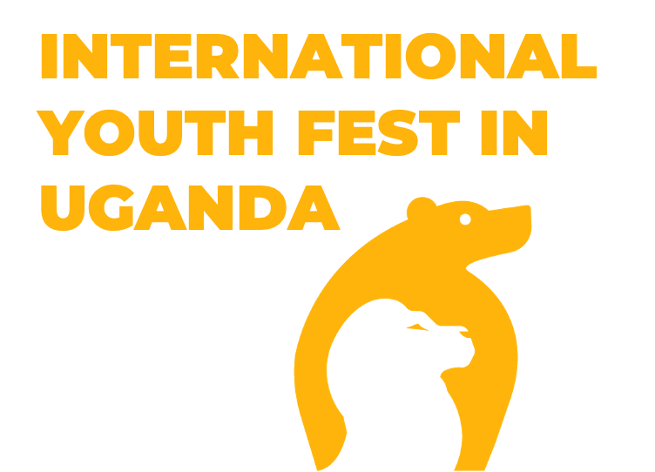

Honorable

13 august 2024

Russia-Africa partnership, especially in the sphere of technology, is a dynamically developing system of relations between states, organizations and people. Communication between ambitious and open-minded youth is a unique part of these relations.

Africa is the youngest continent of our planet that is why the communications of youth will become the basis of full cooperation for years to come.

Work with youth is an investment in decades of the efficient mutual promotion of development.

            Youth festival in Uganda will be organized on 4-5th October 2024. We expect commercial organizations from Russia and Africa, NGO and youth to take part in our sessions. Main issues we plan to discuss during the festival are “Nuclear for Africa”, “Ecology: economical use of natural resources”, “Cultural identity and education”,”Healthcare”.  We expect more than 1600 participants from 45 African countries.

CONTACTS

Website: [internationalyouthfest.com](http://internationalyouthfest.com) | + 7 968 964 97 84 | press@internationalyouthfest.com

            Youth festival in Uganda is held in two cities of the country – Kampala and Jinja. The first day of the festival is devoted to the aspects of international cooperation mentioned above. The second day of the festival is a cultural exchange day between nations of Russia and Africa. Invited actors, singers and dancers perform gala concert. In addition, during the second day we plan to organize the exhibition of our partners.

            We cordially invite you to take part in the event and look forward further cooperation.

**PARTHNERS**